ASSIGNMENT 2

PHARMA SALES DASHBOARD

DATASET:Pharma-Sales-Dataset

1.Sales by customer

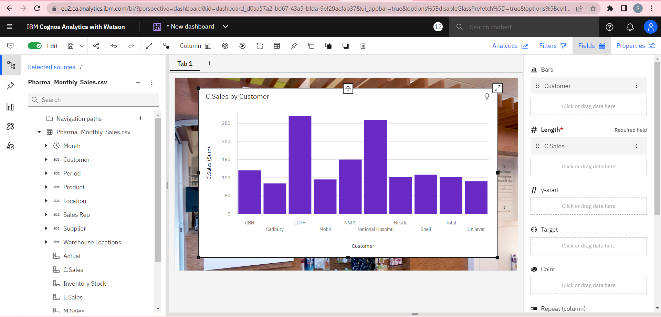

2.Sales by Location

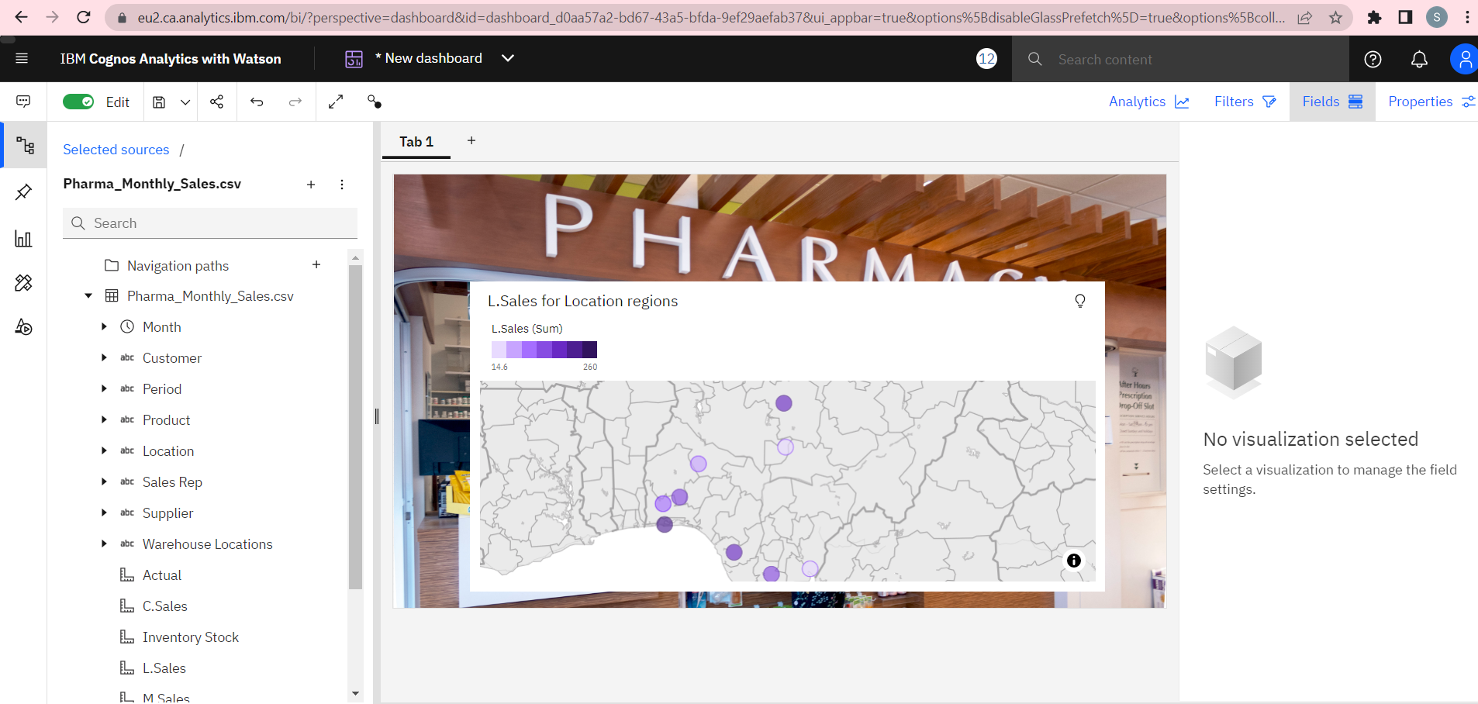

3.Sales by sales Representative

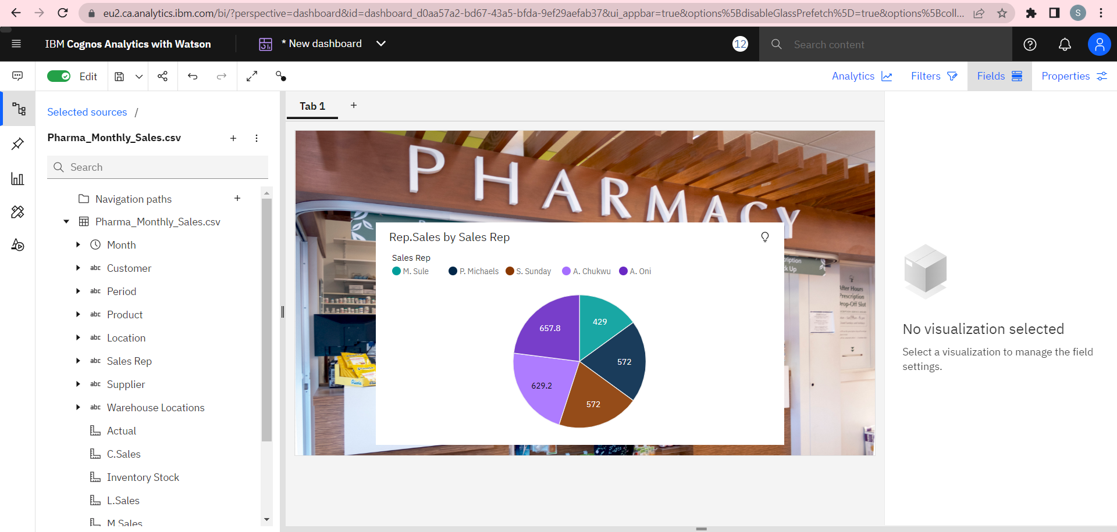

4.Received Inventory from supplier

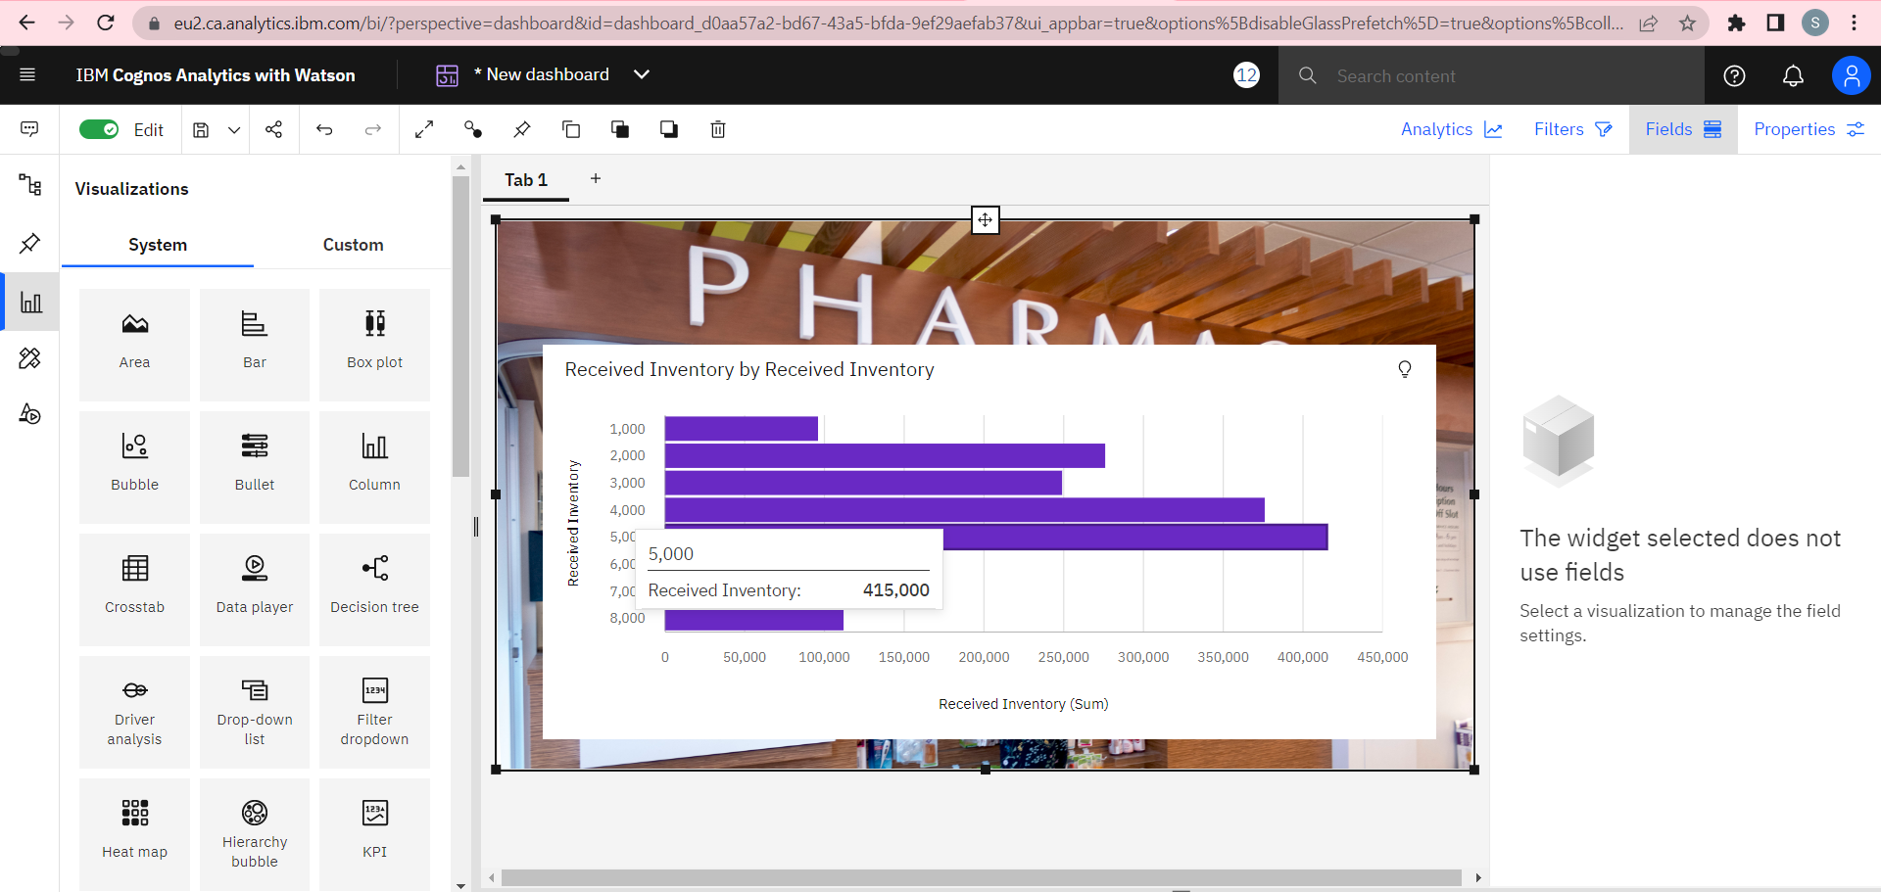

5.Inventory Stock for warehouse location

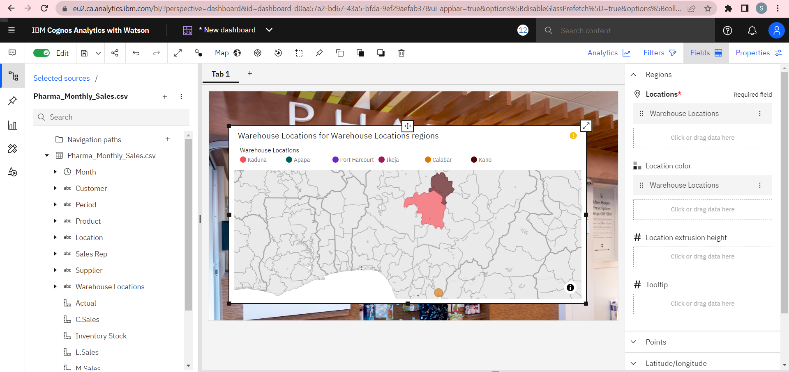

6.Sales Trend

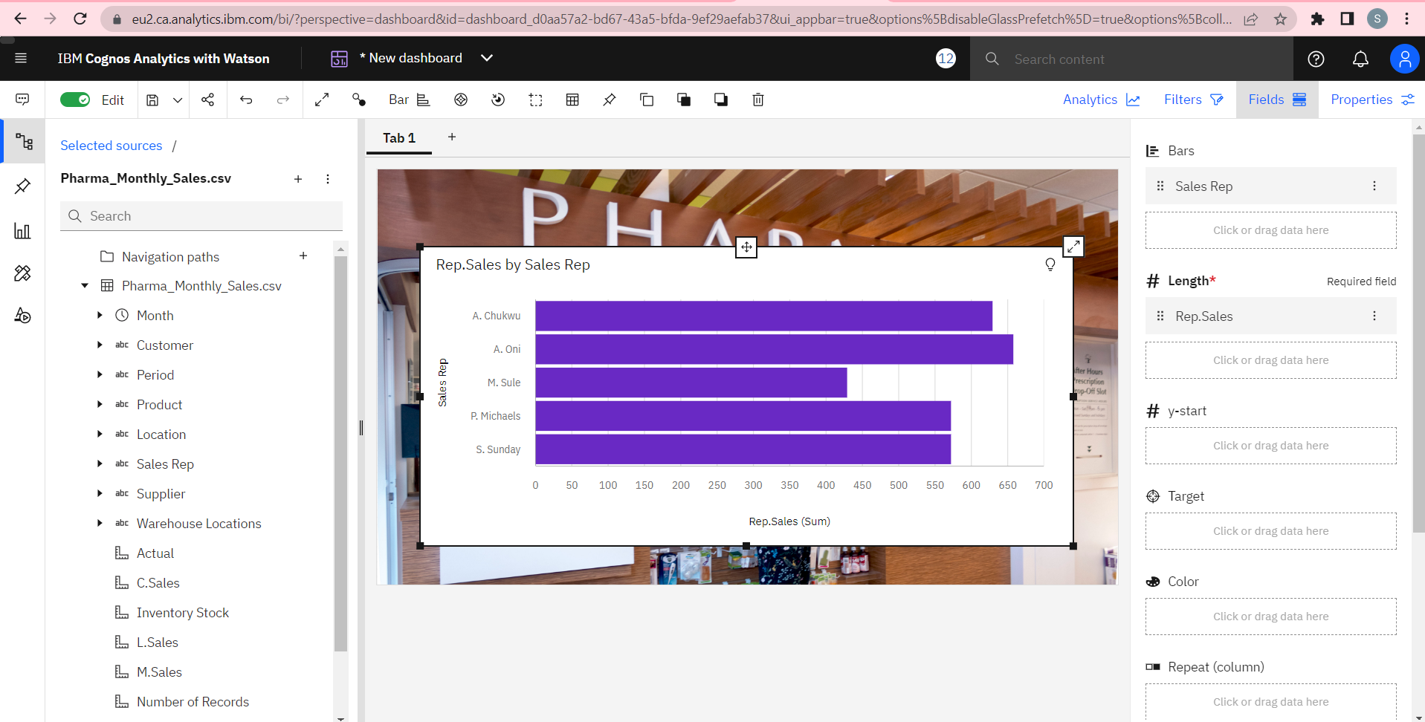

7.Monthly Sales

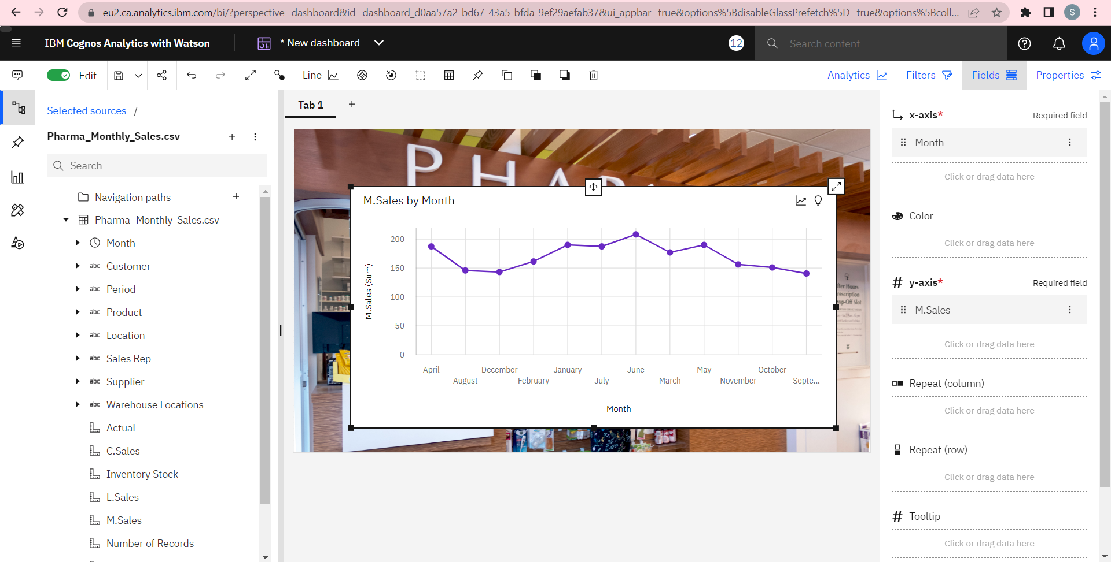

8.Actual and Received Inventory by Month

